Unit 5 Why do you like pandas?
Section A 1a—1c ( P25)

* 教师寄语：Love me, love my dog. 爱屋及乌。

【学习目标】【学习重点】：
1、初步掌握第25页的生词和句型；
2、描述动物，谈论喜好。

【体验学习】：
I、预习交流
1. 根据音标拼读单词并牢记；
2. 自学课文，勾画出重点和疑惑。
II、翻译官
1. welcome to the zoo ___________ 2. my favorite animals ______________
3. want to see them______________ 4. 大象_________________________
5. 树袋熊，考拉 ______________ 6. 长颈鹿________________________

【课堂导学】：
I、新课呈现
Step1 Brainstorming(头脑风暴)
Try to speak out the names of animals you know.
Step2 Presentation
(1) Learn the new words about animals using some pictures.
(2) Present key sentences with these pictures.
—Let’s see the pandas first. —Why do you want to see them?
—Because they’re very cute.
(3) Finish 1a, and then check the answers.
Step3 Listening
Listen and finish 1b. Check the answers.
Step4 Pair work
Talk about the animals in 1a.
II、合作交流
Group work: 你知道多少动物的英文表达？能写出来吗？ Notes:__________________________________________________ _______
_________________________________________________________
_________________________________________________________

【自主检测】：
I、精挑细选
（ ）1. Which kind of animals have long legs and neck?
A. Pandas B. Penguins C. Giraffes
（ ）2. ______ is the biggest animal on the earth. 21世纪教育网
A. An elephant B. A koala C. A giraffe
（ ）3. —Why do you like koalas? —_____ they are cute and smart.
A. So B. But C. Because
（ ）4. There is _______ elephant in the zoo. _______ elephant is from Africa.
A. a; the B. an; the C. an; An
（ ）5. _______ see the giraffes.
A. Let’s me B. Let’s C. Let we

II、“译”展身手
1. 欢迎来到动物园！
_________ ________ the zoo!21世纪教育网
2. 让我们先看熊猫吧！
_________ see the pandas _______!
3. 你为什么想去看狮子？
_________ do you ________ ________see lions?21世纪教育网

【快乐链接】 英汉对对碰：Match each word with the right Chinese meaning.[来源:21世纪教育网]

dolphin 袋鼠   penguin 兔子  kangaroo 海豚  horse 企鹅  rabbit 马 | wolf 鹰  bear 孔雀  eagle 天鹅  peacock 狼  swan 熊


【学习体会】
成功&收获: 失败&不足:

Unit 5 Why do you like pandas?
Section A 2a—2d ( P26)

* 教师寄语：Love me, love my dog. 爱屋及乌。

【学习目标】【学习重点】：
1、学习掌握本节课的生词和短语；
2、描述动物，谈论喜好。
3、提高学生的听说能力。

【体验学习】：
I、预习交流
1. 根据音标拼读单词并牢记；
2. 自学课文，勾画出重点和疑惑。
II、翻译官
1. really scary________________ 2. kind of___________________
3.South Africa________________ 4. be from__________________
5. walk on two legs____________ 6. sleep all day_______________

【课堂导学】：
I、新课呈现
Step1 Free talk
Get the students to talk about their favorite animals.
Step2 Presentation
Present key sentences in this period.
Where are they from? They’re from Africa.
He can walk on two legs. He sleeps all day.
That’s a good name for her.
Step3 Listening21世纪教育网
Listen and finish 2a and 2b. Check the answers.
Step4 Pair work
Talk about the animals in 2a.
Step5 Role-play
Role-play the conversation in 2d.
II、合作交流
Group work: 你能把描述动物的形容词都写下来吗？
Notes:_____________ ____________________________________________
_________________________________________________________
【自主检测】：
I、精挑细选
( )1. What do you want _________?21世纪教育网21世纪教育网
A. eat B. to eat C. eating
( )2. Pandas are ________cute.
A. kinds of B. a kind of C. kind of
( )3. He can walk________ two legs.
A. in B. on C. at
II、补全对话21世纪教育网
A：Let’s see the elephant first.
B：The elephants? Why do you want to see elephants?
A：(1)_________________
B：(2)_________________
A：They’re from South Africa. (3)_____ ____________
B：My favorite animal is panda.
A：(4)_________________
B：Because they’re very cute.
A：(5)_________________
B：They’re over there! Let’s go!

【快乐链接】
各国代表性动物
Panda (熊猫)：大熊猫憨态可掬，是中国的国宝，被动物学家称为“活化石”。
Kangaroo (袋鼠)：被澳大利亚人视为国家的象征。澳大利亚的国徽上就有袋鼠的形象。
Bald eagle (白头海雕)：美国的国鸟，是一种大型猛禽。
Bear (熊)：俄罗斯的代表动物。

【学习体会】
成功&收获: 失败&不足:

[来源:21世纪教育网]
Unit 5 Why do you like pandas?
Section A Grammar Focus—3c ( P27)

* 教师寄语：Love me, love my dog. 爱屋及乌。

【学习目标】【学习重点】：
1、总结归纳Section A部分语法重点；
2、并将所学知识学以致用。

【体验学习】：
I、预习交流：
- 根据Grammar Focus, 归纳Section A部分语法重点；
- 勾画出重点和疑惑。
II、翻译官
1. a lot________________________ 2. black and white______________
3. you’re right __________________
4. 你为什么不喜欢狮子？______________________________________
5. 因为它们真的很恐怖。______________________________________
III、完成第27页3a,3b。

【课堂导学】：
I、新课呈现
Step1 Review
Review the new words in Section A.
Step2 Presentation
Read the sentences in Grammar Focus and try to remember them by heart.
Step3 Practice
(1) Check the answers in 3a. Read the sentences.
(2) Finish 3b. Get the students to write their own sentences.
Step4 Game
Ask and answer questions to guess each other’s animal.
Ⅲ、合作交流
Group work: 分析总结Section A的重点句型，并练习造句。 Notes:_________________________________________________________
_________________________________________________________
_________________________________________________________[来源:21世纪教育网]
_________________________________________________________

【自主检测】：
I、精挑细选
（ ）1. Why _______ you like lions?
A. not B. don’t C. aren’t
（ ）2. ______ pandas are really cute, ______ I like them very much.
A. Because, so B. So, because C. Because, /
（ ）3. She______ Australia.
A. be from B. is from C. are from
（ ）4. She likes dogs _______.
A. a lot B. a lot of C. lot of21世纪教育网[来源:21世纪教育网]

II、完形填空
My parents and I like animals. And we often go to the 1 to see them ___2__ weekends. We often ___3__a bus to go there because my home is 4__far from the zoo. Of all the animals, I __5___tigers best. Sometimes I want 6 some meat to 7 . 8 my parents don’t let me do it. Sometimes I think animals in the zoo may want to go back to the forest. But I also think zoos are good places 9 animals. People give them 10 , so they’re not hungry every day. Do you think so?
（ ）1. A. library B. zoo C. park[来源:21世纪教育网]
（ ）2. A. on B. in C. at
（ ）3. A. by B. take C. in
（ ）4. A. a kind of B. kind of C. kinds of
（ ）5. A. meet B. like C. hope
（ ）6. A. give B. gives C. to give
（ ）7. A. them B. us C. you
（ ）8. A. So B. And C. But
（ ）9. A. on B. at C. for
（ ）10. A. water B. food C. help

【学习体会】
成功&收获: 失败&不足:

Unit 5 Why do you like pandas?
Section B 1a— 1d ( P28 )

* 教师寄语：A cat has nine lives. 吉人天相。
21世纪教育网
【学习目标】【学习重点】：
1、描述动物，谈论喜好。
2、能听懂有关谈论喜好的对话并进行自由交际。[来源:21世纪教育网]

【体验学习】：
I、预习交流
1. 根据音标拼读单词并牢记；
2. 自学课文，勾画出重点和疑惑。
II、翻译官
1. friendly _________________ 2. shy __________________
3. 美丽的__________________ 4. 懒惰的_______________
5. What animals do you like?______________________________
6. I like dogs because they’re friendly and smart.
____________________________________________________

【课堂导学】：
I、新课呈现
Step1 Revision
Review the words and key sentences we’ve learned in Section A.
Step2 Presentation
(1) Learn the new description words in 1a.
(2) Finish 1a, then check the answers.
Step3 Listening
- Listen and finish 1b. Check the answers.
- Listen again. Finish 1c. Check the answers.
Step4 Pair work
Talk about the animals.
II、 合作交流
Group work: 分析总结表达喜好的句型，并练习造句。 Notes:_________________________________________________________
_________________________________________________________
_________________________________________________________

【自主检测】：21世纪教育网
快乐阅读：
Welcome to the zoo!
Opening | Fees
Monday to Friday | Adults(成人)：$ 8.00
10:00 a.m. – 6:00 p.m. | 15 – 18: $ 6.00
Saturday to Sunday | 8 – 14: $ 3.00
8:00 a.m. – 8: 00 p.m. | Under 8: free(免费)
( ) 1. On Sunday, the zoo opens at_______.
A. 10:00 in the morning B. 8:00 in the morning C. 8:00 in the afternoon[来源:21世纪教育网]
( )2. The zoo opens ______ days a week.
A. two B. five C. seven
( )3. If you are 13 years old, and you want to go to the zoo, you should pay______.
A. $ 3 B. $ 6 C. $ 8
( )4. Kate is 12, and her little sister is 6. If they go to the zoo, they should pay____.
A. $ 8 B. $ 6 C. $ 3
( )5. The zoo closes (关) at ________ on Wednesday.
A. 10:00 a.m. B. 6:00 a.m. C. 6:00 p.m.

【快乐链接】 英汉对对碰：Match each sentence with the right Chinese meaning.

Love me, love my dog.  Every dog has its day.  Beat the dog before the lion.  A cat has nine lives.  Fine feathers make fine birds. | 杀鸡给猴看。  人要衣装，佛靠金装。  每个人都有得意的日子。  爱屋及乌。  吉人天相。
[来源:21世纪教育网]
【学习体会】

成功&收获: 失败&不足:

Unit 5 Why do you like pandas?
Section B 2a— 2c( P29 )

* 教师寄语：A cat has nine lives. 吉人天相。

【学习目标】【学习重点】：
1、描述动物，谈论喜好。
2、能阅读较长文章并完成练习。
21世纪教育网
【体验学习】：
I、预习交流
1. 根据音标拼读单词并牢记；
2. 自学课文，勾画出重点和疑惑。
II、翻译官
1. save the elephants__________ 2. one of Thailand’s symbols_________
3. get lost __________________ 4. be in great danger________________
5. 砍倒____________________ 6. made of ivory___________________
7. An elephant never forgets.________________________________________
8. People also kill elephants for their ivory._____________________________
III、完成第29页2b和2c。

【课堂导学】：
I、新课呈现21世纪教育网
Step1 Free talk
T: Talk about the animals you think are in great danger.
Step2 Presentation
- Learn the new words in 2b.
- Read the website article and check the best title for it. Check the answers.[来源:21世纪教育网]
- Read the article again and finish 2c. Check the answers.
Step3 Group work
Discuss the difficulties you found in 2b. Try to understand the article.
Step4 Consolidation
Retell the article according to the mind map.
II、 合作交流
Group work: 分析总结如何画好课文导图。 Notes:_________________________________________________________
_________________________________________________________
_________________________________________________________
【自主检测】：
I、连词成句
- is, this, luck, a, of, symbol, good (.)
___________________________________________________________
- elephants, great, are, danger, in (.)
___________________________________________________________
- trees, must, the, save, people (.)
___________________________________________________________21世纪教育网
II、“译”展身手
Today is Sunday. It is sunny(晴朗的). (1 ) Dale and Tom don’t go to school. They want to go to the zoo, ( 2 ) because there is an elephant in the zoo. They take a bus to the zoo. After one hour, they get to the zoo. They see the elephant. ( 3 ) 她真的很漂亮。Her name is Ling. ( 4 ) 她来自非洲。She is only five years old. She’s very quiet. Children(孩子们) like her a lot. ( 5 ) They want to play with her, but Ling is very shy. People in the zoo tell them to be quiet.
( 1 )
( 2 )
( 3 )
( 4 )
( 5 )
【快乐链接】 Birds that can’t fly
Penguins are birds, but they can’t fly. They can stand and walk.
It’s very interesting to see penguins walking. When they walk, they 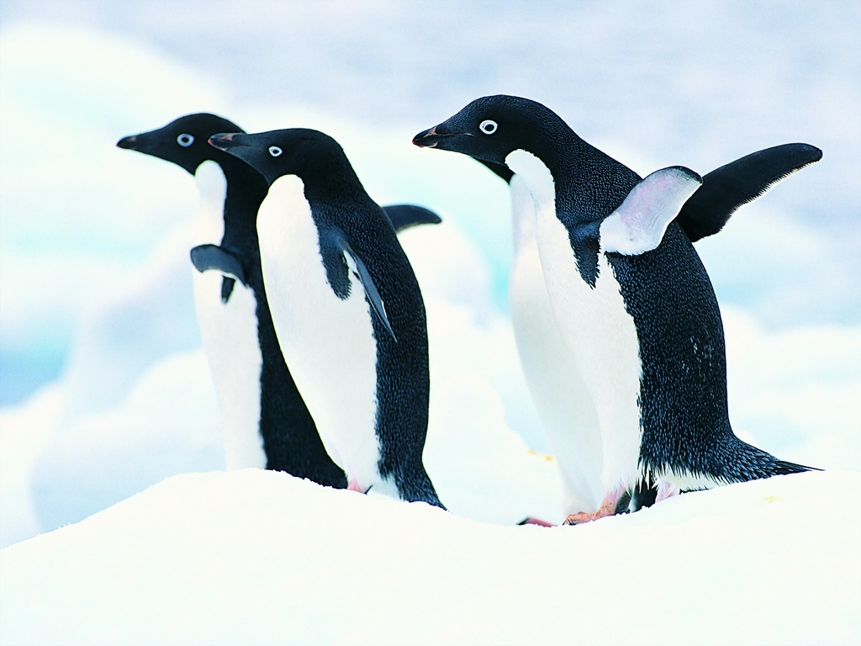
sway their bodies. It makes them look cute and funny. Penguins are short and fat. With black backs and white bellies(腹部), they look like gentlemen wearing tailcoats. Penguins live in cold places so they must eat a lot. Fish are their favorite food.
Answer the following questions.
1. Can all the birds fly?
2. What is penguins’ favorite food?

【学习体会】
成功&收获: 失败&不足:

Unit 5 Why do you like pandas?
Section B 3a— Self Check ( P30 )

* 教师寄语：A cat has nine lives. 吉人天相。

【学习目标】【学习重点】：
1、复习描述动物，谈论喜好。21世纪教育网
2、描述自己喜欢的动物。

【体验学习】：
I、预习交流
1. 根据音标拼读单词并牢记；
2. 自学课文，勾画出重点和疑惑。21世纪教育网
II、翻译官
1. Isn’t she beautiful?____ _______________________________________
2. She is from Africa. ___________________________________________ [来源:21世纪教育网]
3. I like dogs because they are friendly and smart._____________________
4. He lives in China. ____________________________________________
III、完成第30页3a, 3b和Self Check。

【课堂导学】：
I、新课呈现
Step1 Free talk
Talk about your favorite animals.
Step2 Presentation[来源:21世纪教育网]
(1) Review new words and phrases.
(2) Review some sentence patterns.
(3) Review how to write our favorite animals..
Step3 Practice
- Finish 3a. Check the answers.
- Finish 1, 2 in Self Check. Check the answers.
Step4 Pair work
Work in pairs and finish 3b. Write down the article.
II、 合作交流
Group work: 分析总结如何描述自己最喜欢的动物。 Notes:_________________________________________________________
_________________________________________________________
_________________________________________________________
【快乐阅读】：
Baboons(狒狒) live in Africa. They are like monkeys. Most people think daddy baboons don’t know their babies. But scientists (科学家) find that daddy baboons know how to help their babies. The daddy baboons are smart.
Joan Silk is a scientist. She studies the baboons for 3 years. She says the daddy baboons are happy to see their babies. They have big teeth to help the babies to eat hard things. Mother baboons are small. And they live in a place. When a mother baboon gives birth(分娩), she often has only one baby. Baby baboons have fur. They are very cute.
During the day and eat things. At night, they sleep in the trees. Most children like baboons because they look like the man.
( ) 1. Where do baboons live?
A. In Africa. B. In America. C. In Canada.
( )2. How are daddy baboons?
A. They are shy. B. They are beautiful.21世纪教育网
C. They are smart.
( )3. They underlined word “hard” means________ in Chinese.
A. 困难的 B. 柔软的 C. 坚硬的
( )4. The mother baboon usually has _______baby baboon(s) when she gives birth.
A. one B. two C. three
( )5. Which of the following is TRUE?
A. Baboons are small monkeys.
B. Baby baboons are very cute.
C. Daddy baboons don’t know how to help their babies.

【快乐链接】 妙趣横生的 “as…as”
1. as blind as a bat(像蝙蝠一样盲目) 2. as busy as a bee(像蜜蜂一样忙碌)
3. as angry as a bull(像公牛一样愤怒) 4. as bald as an eagle(像鹰一样秃顶)
5. as sly as a fox (像狐狸一样狡猾) 6. as brave as a lion(像狮子一样勇敢)

【学习体会】
成功&收获: 失败&不足

